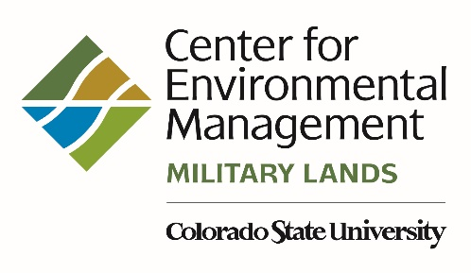

1490 Campus Delivery
Fort Collins, Colorado 80523-1490
Telephone (970) 491-2748

Dear ,

This letter is a formal notification that funding for your position will end on . As discussed with you, your employment with Colorado State University (CSU) will end on the same date.

If you wish your health care coverage to continue after the last day of the last month in which you will work, please contact CSU’s Benefits Office at (970) 491-6947 or hr_service_center@mail.colostate.edu to determine whether you are eligible for COBRA and to coordinate premium payments. The Benefits Office also can answer questions regarding your retirement accounts and other benefits. Information on payment for accrued annual leave is in section 2, pages 9-10 of the Faculty and Administrative Professional Handbook (http://www.hrs.colostate.edu/pdfs/hrs-manual-2-faculty-admin-pro.pdf). If your mailing address changes before the end of the year, please let us know so we can send your W-2 to the correct address.

If you are interested in other employment opportunities with CEMML, please visit https://jobs.colostate.edu/

We appreciate your contributions to CSU, CEMML, and . Please feel free to contact me if you have questions.

Sincerely,

cc: Julie Orwick, Warner College of Natural Resources
Angela Thompson, Warner College of Natural Resources

